EXP 3: Determination and plotting of Force of attraction between two electric Charges and two parallel conductors separated by varying distance.
Aim:
To Determination and plotting of Force of attraction between two electric Charges and two parallel
conductors separated by varying distance between them using SCILAB.

Software required:
•SCILAB version 6.0.1
Program:
clc;
clear;
// Given values
charge_1 = 5 * 10^-6; // Coulomb
charge_2 = 3 * 10^-6; // Coulomb
radius = 3 * 10^-2; // 3 cm = 0.03 m
current_1 = 1; // Ampere
current_2 = 2; // Ampere
l = 2 * 10^-3; // 2 mm = 0.002 m
d = 3 * 10^-2; // 3 cm = 0.03 m
// Constants
mu = 4 * %pi * 10^-7;
epsilon = 8.854 * 10^-12;
// Coulomb's Force
F = (charge_1 * charge_2) / (4 * %pi * epsilon * radius^2);
// Force between two parallel conductors
f = (mu * current_1 * current_2 * l) / (2 * %pi * d);
// Display results
disp("THE FORCE BETWEEN TWO ELECTRIC CHARGES (N):");
disp(F);
disp("THE FORCE BETWEEN TWO PARALLEL CONDUCTORS (N):");
disp(f);
// Graph
x = linspace(0, 10, 50);
y = F * exp(-0.1 * x);
z = f * exp(-0.1 * x);
figure();
subplot(2,2,1);
plot2d3(x, y);
xlabel("R");
ylabel("Force (N)");
title("FORCE BETWEEN TWO ELECTRIC CHARGES");
subplot(2,2,2);
plot2d3(x, z);
xlabel("D");
ylabel("Force (N)");
title("FORCE BETWEEN TWO PARALLEL CONDUCTORS");
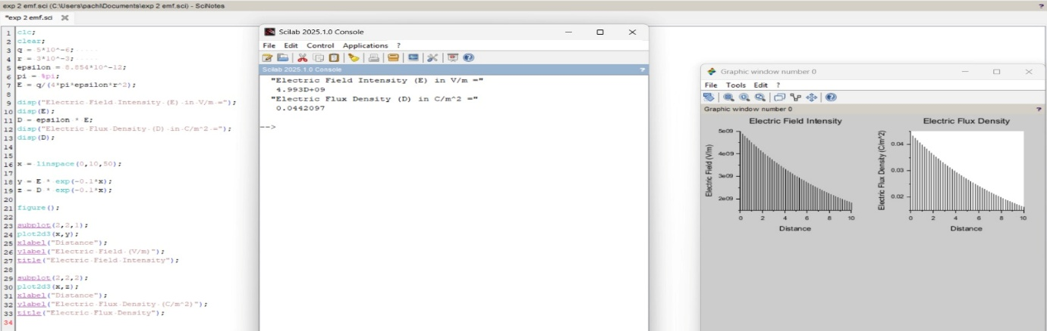
OUTPUT ;
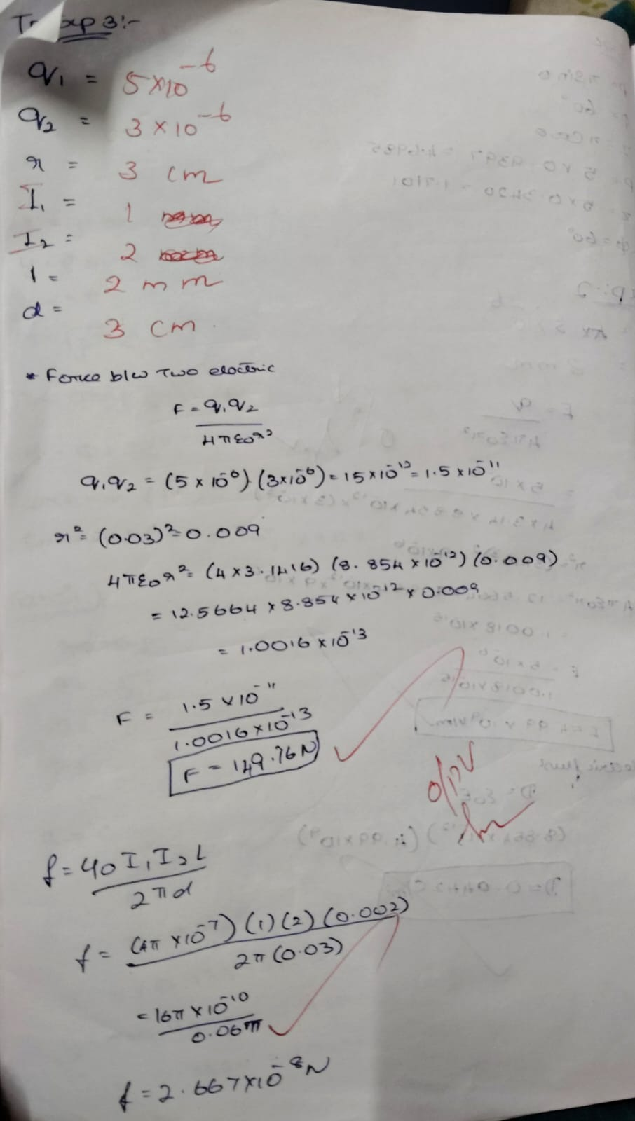
Case 1 :Given two point charges q1=2×10^−6 and q2=3×10^−6 C, calculate and plot the force of attraction between them as a function of distance, ranging from 0.1 m to 10 m. Explain how the force changes with the distance between the charges.
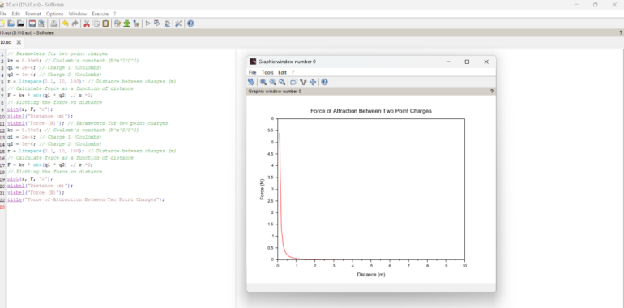
Case 2:Given two point charges q1=5×10^−6 C and q2=2×10^−6 , calculate and plot the force of attraction between them as the distance varies from 0.5 m to 5 m. Discuss how the force behaves with the varying distance and charge magnitudes.
